Cross-quantilogram: AUDUSD and NZDUSD
Method 20 / daily log returns / expanding quantiles / Alpari D1 full available history

Study setup
Logical pair: AUDUSD , NZDUSD
Broker symbols: AUDUSD_i , NZDUSD_i
Snapshot: 2026-11-03_majors_alpari_D1
Timeframe: D1
Matched return window: 1999-01-05 to 2026-11-02 (UTC bar dates)
Matched return count n: 7202
Dropped unfinished last bar dated 2026-11-03 UTC after a tick-volume check against the prior complete day.
Quantiles: expanding window, min history 252 days
tau in [0.05, 0.2]; k=0..10; headline tau=0.05, k=1
Complete matched rows (Excel): AUDUSD-NZDUSD_CQ_D1.xlsx
Complete matched rows (HTML table): AUDUSD-NZDUSD_CQ_D1_data.html

Method carried forward
The cross-quantilogram rho_tau(k) measures linkage among centered quantile-hit indicators of matched daily log returns of close, ln(close_t / close_t-1). Quotes are not inverted. At each date t, the tau-quantile uses only returns through t (expanding window) after a minimum history of 252 days. Hits are h_t = 1(r_t < q_t) - tau. rho_tau(k) is the normalized cross-product of h_x,t with h_y,t+k. Levels tau in {0.05, 0.20} and lags k=0..10 are pre-specified; headline is tau=0.05, k=1 both directions. Same-sample Pearson r is a side check. This is not causation and not a trading signal.

Results (headline)
rho_AUDUSD->NZDUSD(tau=0.05,k=1): 0.081830
rho_NZDUSD->AUDUSD(tau=0.05,k=1): 0.052044
rho_AUDUSD->NZDUSD(tau=0.20,k=1): 0.031190
rho_NZDUSD->AUDUSD(tau=0.20,k=1): 0.018117
Pearson r: 0.828722

CQ table (tau=0.05)
k | rho_AUDUSD_to_NZDUSD | n_AUDUSD_to_NZDUSD | rho_NZDUSD_to_AUDUSD | n_NZDUSD_to_AUDUSD
0 | 0.5815862 | 6951 | 0.5815862 | 6951
1 | 0.08183032 | 6950 | 0.05204375 | 6950
2 | 0.0586552 | 6949 | 0.04541662 | 6949
3 | 0.02886035 | 6948 | 0.02886035 | 6948
4 | 0.07849783 | 6947 | 0.05202022 | 6947
5 | 0.05532211 | 6946 | 0.05532211 | 6946
6 | 0.032146 | 6945 | 0.02552649 | 6945
7 | 0.05530647 | 6944 | 0.05199669 | 6944
8 | 0.04867904 | 6943 | 0.05198885 | 6943
9 | 0.04205149 | 6942 | 0.03212198 | 6942
10 | 0.0288041 | 6941 | 0.05197316 | 6941

Conclusion
Headline tau=0.05, k=1 for AUDUSD and NZDUSD: rho_AUDUSD->NZDUSD = 0.0818; rho_NZDUSD->AUDUSD = 0.0520. At tau=0.20, k=1: 0.0312 and 0.0181. Same-day tau=0.05 rho(k=0) = 0.5816. Pearson r = 0.8287. This is quantile-hit linkage, not a trading signal.

Charts
Daily closes

Daily log returns

Cross-quantilogram tau=0.05
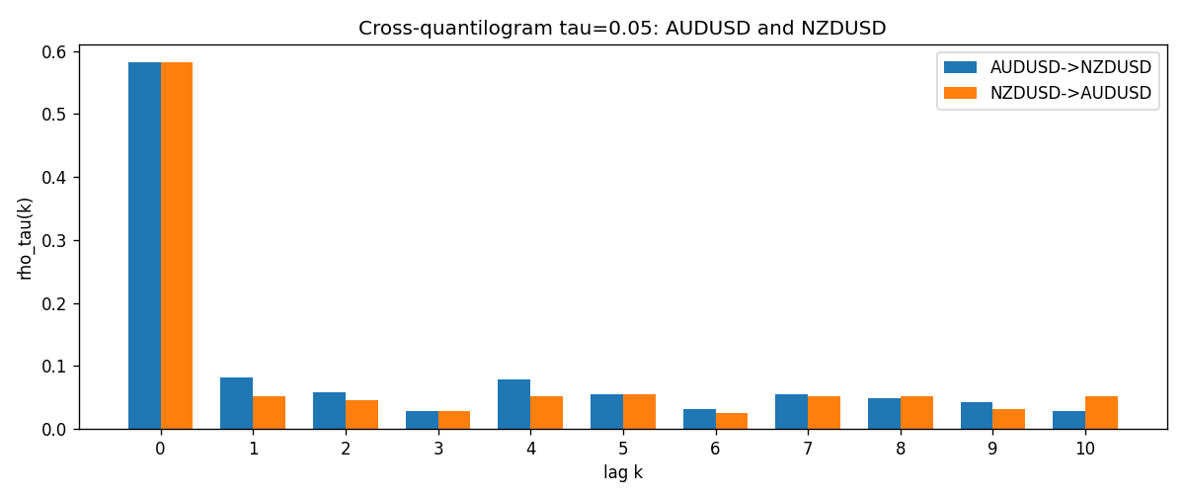

Data report
Matched rows and the CQ sheet are in the sibling Excel workbook named AUDUSD-NZDUSD_CQ_D1.xlsx. Embedding all rows as a Word table is impractical; this file holds column summaries and the first and last 15 matched rows.
Columns: time, AUDUSD_open, NZDUSD_open, AUDUSD_high, NZDUSD_high, AUDUSD_low, NZDUSD_low, AUDUSD_close, NZDUSD_close, AUDUSD_tick_volume, NZDUSD_tick_volume, AUDUSD_spread, NZDUSD_spread, AUDUSD_real_volume, NZDUSD_real_volume, AUDUSD_log_return, NZDUSD_log_return, AUDUSD_h_t005, NZDUSD_h_t005
Column summaries (matched calculation rows)
column | count | mean | std | min | 25% | 50% | 75% | max
AUDUSD_open | 7202 | 0.75190973 | 0.13530408 | 0.4785 | 0.6610275 | 0.731395 | 0.8089525 | 1.10284
NZDUSD_open | 7202 | 0.65620671 | 0.10825448 | 0.3913 | 0.5910925 | 0.6683 | 0.724695 | 0.88218
AUDUSD_high | 7202 | 0.75595988 | 0.13586572 | 0.4878 | 0.6647 | 0.734725 | 0.81501 | 1.10795
NZDUSD_high | 7202 | 0.66012182 | 0.1087492 | 0.3961 | 0.5946275 | 0.67189 | 0.7292675 | 0.88421
AUDUSD_low | 7202 | 0.74785283 | 0.13461673 | 0.4775 | 0.6577 | 0.727385 | 0.8042 | 1.0975
NZDUSD_low | 7202 | 0.6525168 | 0.10784895 | 0.3897 | 0.587955 | 0.66406 | 0.72082 | 0.87988
AUDUSD_close | 7202 | 0.75195766 | 0.13528533 | 0.4786 | 0.6611925 | 0.731645 | 0.809065 | 1.10169
NZDUSD_close | 7202 | 0.65627751 | 0.10825012 | 0.3907 | 0.59141 | 0.668305 | 0.7249175 | 0.8822
AUDUSD_tick_volume | 7202 | 77337.3 | 138128.78 | 109 | 5435.5 | 43320 | 71312.25 | 1234623
NZDUSD_tick_volume | 7202 | 68561.899 | 123036.41 | 17 | 5505.5 | 33822 | 58470.25 | 1127682
AUDUSD_spread | 7202 | 30.821161 | 16.887481 | 0 | 13 | 30 | 50 | 50
NZDUSD_spread | 7202 | 30.366287 | 25.672101 | 0 | 9 | 17 | 50 | 80
AUDUSD_real_volume | 7202 | 5.2413627e+09 | 1.253718e+11 | 0 | 0 | 0 | 0 | 3.811512e+12
NZDUSD_real_volume | 7202 | 1.6659405e+10 | 8.488719e+10 | 0 | 0 | 0 | 0 | 2.705649e+12
AUDUSD_log_return | 7202 | 2.237e-05 | 0.00754318 | -0.08602525 | -0.00386318 | 0.00028132 | 0.00415217 | 0.0806166
NZDUSD_log_return | 7202 | 5.13e-06 | 0.00764596 | -0.07027433 | -0.00426304 | 0.00021271 | 0.00457975 | 0.05966839
AUDUSD_h_t005 | 6951 | -0.003388 | 0.21082152 | -0.05 | -0.05 | -0.05 | -0.05 | 0.95
NZDUSD_h_t005 | 6951 | -0.00554596 | 0.20611644 | -0.05 | -0.05 | -0.05 | -0.05 | 0.95
First 15 matched rows (selected columns)
time | AUDUSD_log_return | NZDUSD_log_return | AUDUSD_h_t005 | NZDUSD_h_t005
1999-01-05 | -0.00080418179 | -0.0018597736 | nan | nan
1999-01-06 | 0.011836351 | 0.0020455609 | nan | nan
1999-01-07 | 0.0088650256 | 0.0062963171 | nan | nan
1999-01-08 | 0.00031515916 | -0.00055396548 | nan | nan
1999-01-11 | 0.0072213815 | 0.010290425 | nan | nan
1999-01-12 | -0.0048608485 | -0.0053157489 | nan | nan
1999-01-13 | -0.0078902098 | -0.0099742238 | nan | nan
1999-01-14 | -0.002696916 | -0.00018564931 | nan | nan
1999-01-15 | 0.007123101 | -0.00074294208 | nan | nan
1999-01-18 | 0.00094592471 | -0.0018597736 | nan | nan
1999-01-19 | 0.0072225153 | 0.0018597736 | nan | nan
1999-01-20 | 0.0012507819 | 0.0040793678 | nan | nan
1999-01-21 | 0.00078094498 | 0.0040627941 | nan | nan
1999-01-22 | -0.012252745 | -0.012051689 | nan | nan
1999-01-25 | -0.0039591468 | -0.0035504102 | nan | nan
Last 15 matched rows (selected columns)
time | AUDUSD_log_return | NZDUSD_log_return | AUDUSD_h_t005 | NZDUSD_h_t005
2026-10-13 | 0.0035007712 | 0.0047326165 | -0.05 | -0.05
2026-10-14 | -0.0015193215 | -0.0037306483 | -0.05 | -0.05
2026-10-15 | -0.0075447063 | 0.0047634855 | -0.05 | -0.05
2026-10-16 | 0.0033906408 | 0.0057501001 | -0.05 | -0.05
2026-10-19 | 0.0050859986 | 0.0018917133 | -0.05 | -0.05
2026-10-20 | 0.0034620426 | 0.0037199341 | -0.05 | -0.05
2026-10-21 | 0.0036066384 | 0.0030923331 | -0.05 | -0.05
2026-10-22 | -0.0012672558 | -0.0033035227 | -0.05 | -0.05
2026-10-23 | 0.0023765656 | 0.0030929853 | -0.05 | -0.05
2026-10-26 | -0.0032032829 | -0.0028993932 | -0.05 | -0.05
2026-10-27 | 0.0016669876 | -0.00026399852 | -0.05 | -0.05
2026-10-28 | 0.0040915541 | -0.0097283914 | -0.05 | -0.05
2026-10-29 | -0.0040915541 | 0.00062190714 | -0.05 | -0.05
2026-10-30 | 0.0010102376 | 0.00019537668 | -0.05 | -0.05
2026-11-02 | -0.0049184984 | -0.0025962955 | -0.05 | -0.05

